Power BI Project

Human Resources Attrition Project

Page 1 -Company Overview

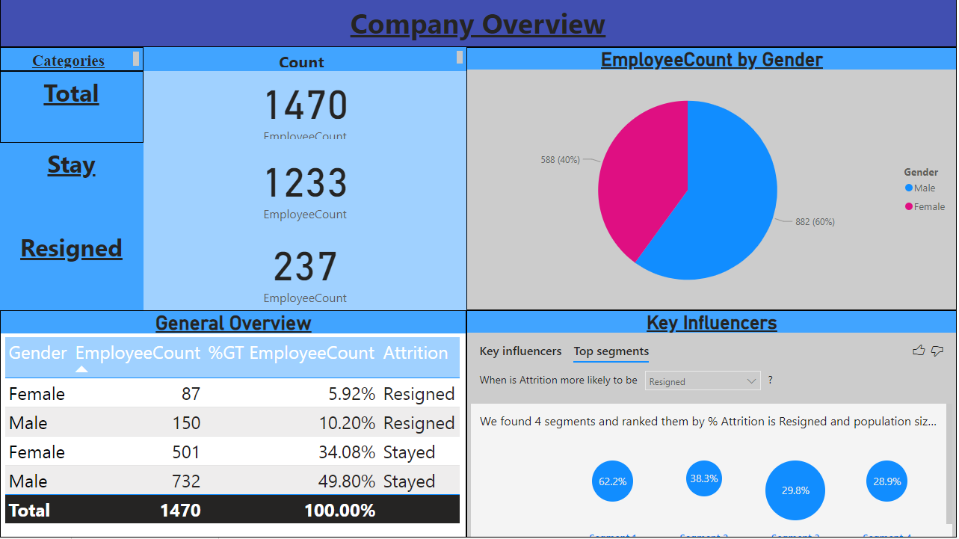

Page 2 – Demographic Overview

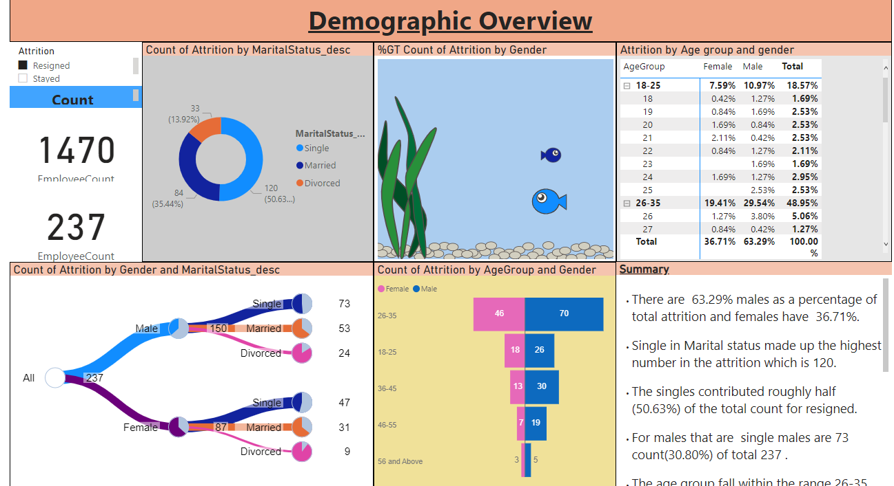

Page 3 – Education Overview

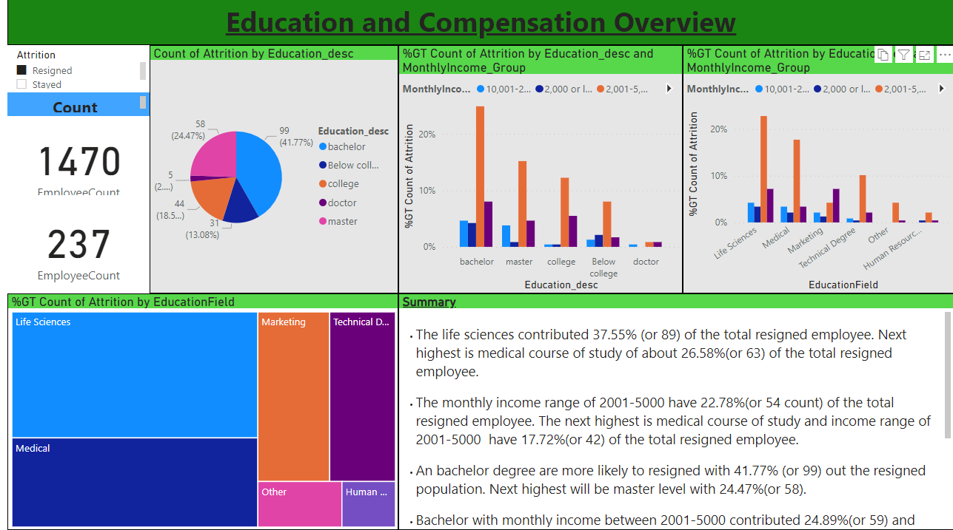

Page 4 –Job Requirement and workload

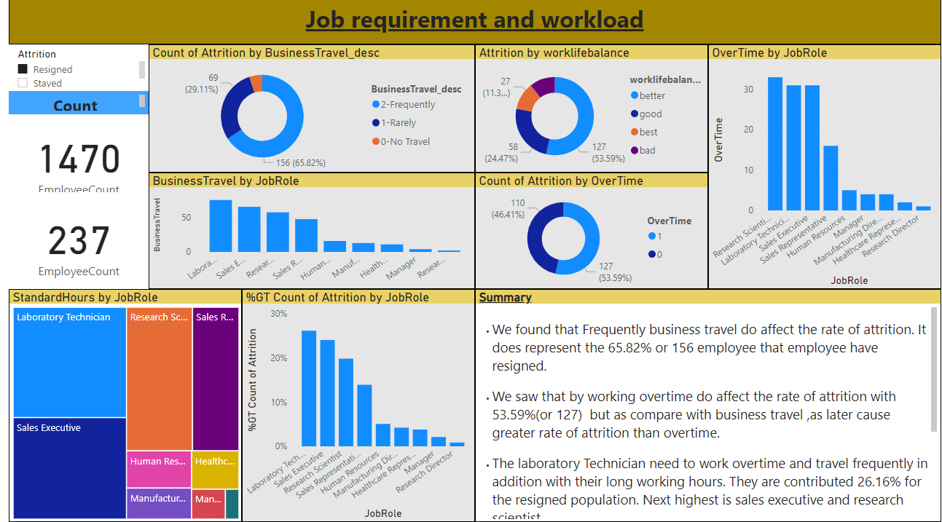

Page 5 – Employees matters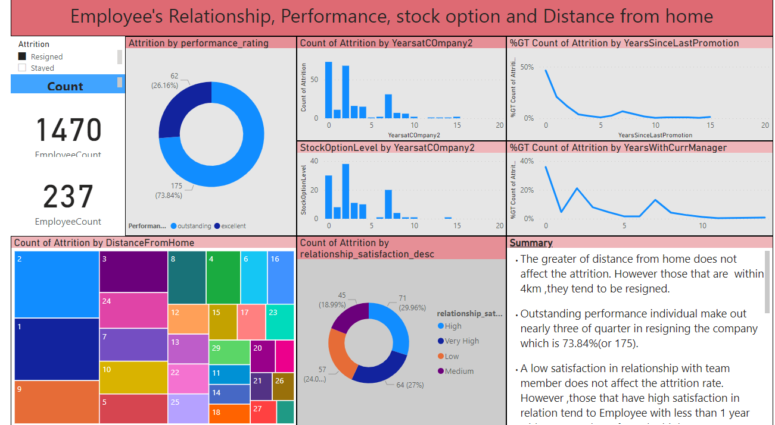

Page 6 -Summary

